Answers to questions from the Student Book

Contents

Chapter 1 — Introducing science

Chapter 2 — Staying alive

Chapter 3 — Changing materials

Chapter 4 — Big changes

Chapter 5 — Safety first

Chapter 6 — Tomorrow’s weather

Chapter 7 — Use it again

Chapter 8 — Water

Chapter 9 — Energy converters

Chapter 10 — Under the skin

Chapter 1 — Introducing science

Chapter questions
1.1.1 What does a geologist study? |  | Geologists study the Earth and the processes that shaped it as it formed and that have changed it through time.
1.1.2. What is pharmacology? |  | The study of drugs, their uses and effects.
1.1.3. What is an important characteristic of scientists? |  | Curiosity and determination to have it satisfied  Enjoyment of learning and applying knowledge in familiar and unfamiliar situations.  Being observant — gathering knowledge from many sources and recognising that different people can view the same information in different ways.  Ability to work well on their own, but also able to work as part of a group.  Ability to gather information, analyse it and reach a conclusion based on information not on emotion.
1.1.4. List three other characteristics of scientists. |  | See answer to question 3.
1.1.5. What skill is listed as necessary for both geologists and pharmacists? |  | The skills they have in common are problem solving skills and good communication skills.
1.2.1. How do we make observations? |  | Using all of our senses.
1.2.2. List three things that influence your observations. |  | Our experience and knowledge.  The amount of attention we are paying.  The amount of training in observation we have had.
1.2.3. Compare quantitative and qualitative observations. (Remember compare means to look at the ways things are similar and the ways in which they are different.) |  | They are both ways of describing what we see. Qualitative observations are made using our senses and they refer to a quality of some kind such as colour or relative distance apart. Quantitative observation deals with measurement. It involves a number and a unit.
1.2.4. What is an inference? |  | Inferences are interpretations of the observations.
1.2.5 What two parts are there to a quantitative observation? |  | A number and a unit.
1.3.1. Describe a fair test. | A fair test is one in which only one variable is changed, one variable is measured and all the other variables are controlled (kept the same).
1.3.2. What is another name for the variable that is:
• Measured? | Dependent variable.
• Changed? | Independent variable.
1.3.3. Why is it important that all the other variables are controlled? | By controlling all the other variables we can be sure that the thing we changed (the dependent variable) has caused the effect — the changes we measured.
1.3.4. Explain why a number of trials are done in a fair test? | To ensure that the result is true every time that the test is carried out. Not just in one set of circumstances.
Review questions
Check
1. Use Worksheet 1.8 to check your knowledge of the key terms. | See answers to worksheets.
2. For each of the following state whether it is a qualitative or quantitative observation.
a. The rock is hard | Qualitative
b. It took me 10 minutes to get to school. | Quantitative
c. The reading on the scale was 2.5 kg. | Quantitative
d. The first pillow I tried was softer than the second one. | Qualitative
e. We had 14 mm of rain last week | Quantitative
3. Make a list of the characteristics of a scientist. | Curiosity and determination to have it satisfied  Enjoyment of learning and applying knowledge in familiar and unfamiliar situations.  Being observant — gathering knowledge from many sources and recognise that different people can view the same information in different ways.  Ability to work well on their own, but also able to work as part of a group.  Ability to gather information, analyse it and reach a conclusion based on information not on emotion.
4. Explain the difference between a dependent variable and an independent variable. | The independent variable is the one that is changed by the person carrying out the experiment. The dependent variable is the one that is measured. The changes to the dependent variable result from (or depend on) the changes made to the independent variable.
Apply
5. Are communication skills important for scientists? Use information from the story about the geologist and the pharmacist to support your answer. | The geologist works in a team therefore has to be able to share ideas with other team members. Geologists write reports and make maps and diagrams to present results to others.  The Pharmacist talks to patients about the correct way to take the medication and any side effects there may be to ensure that medication is used safely and in a way that will be effective. They also write technical reports to share their knowledge with the medical profession and other pharmacists.
6. How is an inference different from a guess? | An inference has observations to support it. This may not be true of a guess.
7. Do you think the police and forensic scientists would use qualitative or quantitative evidence when presenting a case in court? Explain. | They would use both types of observations. Where something can be measured they would make the measurements and present quantitative information. In other situations descriptions – supported by photographs when possible, are presented.
8. In an experiment, why is it important to control the factors that are not being investigated? | To ensure that they are the same in all trials and that any changes in them are not responsible for the measured change in the dependent variable.
9. a Imagine you have been asked to design an experiment to find out whether salt or sugar dissolved more easily. What would be the:
i. Independent variable? | Whether the test substance was salt or sugar.
ii. Dependent variable. | The time it took for the substance to dissolve. Alternatively, the amount of water required to dissolve the substance
b Suggest two other variables you would have to control. | The size of the salt and sugar crystals.  Temperature of the water.  Amount of water (unless it was being measured).  The amount of stirring.
Challenge
10. Why is it important that pharmacists study pharmacy law? | Everyone needs to know the rules and regulations impacting on their profession. Many drugs are available to only certain groups of people and can be sold in predetermined quantities. Some can be sold over the counter others by prescription only. These rules ensure that only the people who need the drugs are provided with them.
11. Suggest ways that you could improve your observation skills. | Practice making observations by looking at familiar things more closely or by using different observational tools such a magnifying glass. Looking at things with a partner and finding out what they see. Learn to listen more carefully – possibly listen with eyes shut so that visual clues are absent. Learn to recognise the smells of familiar household substances. Touch things so that you become familiar with their feel and can recognise when there are changes or when two things that look the same are in fact different.  Taste more foods to challenge your taste buds.  DO NOT use the sense of taste in unfamiliar situations. All clear liquids are not water and all fruits are not safe to eat.
12. Use the internet to find the name of a famous scientist. State when he or she lived and describe in your own words what they are famous for. (The Eureka People’s Choice website could be a good place to start.)
13. Think about ways you are working as a scientist in your everyday life. Select one of the ways and draw a picture or write a few sentences to show others your idea. | Observing how ingredients mix together and change in the cooking process. Trying variations in recipes either in the ingredients or in the relative quantities of ingredients.  Observing how the body move in new sporting experiences as you learn to do complete actions more efficiently and effectively.

Chapter 2 — Staying alive

Chapter question
2.1.1. If an eagle is eating a rabbit which of the animals is the predator? |  | The eagle.
2.1.2. How does camouflage protect prey animals? |  | They blend into their surroundings and the predator cannot see them.
2.1.3. Name two other ways that prey animals can escape their predators. |  | Running away; mimicry; being poisonous or having an unpleasant taste.
2.1.4. Why is a cheetah such an efficient predator? |  | It can run very fast when chasing its prey. The colour of its fur provides camouflage so it can move unseen through the vegetation as it creeps up on its prey.
2.1.5. Describe one way that plants protect themselves from being eaten. |  | Having spines or containing chemicals that make them unpleasant to eat.
2.2.1. What is an adaptation? |  | A characteristic of a living thing that helps it stay alive in its environment.
2.2.2. Why do spiders make webs? |  | To capture their prey.
2.2.3. How do spiders avoid being trapped in their own webs? |  | Some of the strands are not sticky and the spider walks on these.
2.2.4. Some spiders do not spin webs. What adaptations could they have that help them catch their food? |  | Some can run quickly. Others hide and wait for their prey to come along and then they pounce on it.
2.2.5. Describe the process of photosynthesis. |  | A complex series of chemical reactions that occurs in the leaves of plants. Energy from the Sun is used to combine carbon dioxide and water to make sugars.
2.3.1. Why is photosynthesis an important process for all living things? |  | Photosynthesis introduces energy into food chains. Although the Sun is the ultimate source of energy for most living things it is the process of photosynthesis that makes the energy available to them.
2.3.2. What is a food chain? |  | The movement of energy through feeding.
2.3.3. What does the arrow in a food chain represent? |  | The direction of movement of the energy.
2.3.4. Explain the difference between a producer and a consumer. |  | A producer is able to trap the Sun’s energy and manufacture its own food. A consumer uses other living things as its source of energy.
2.3.5. Explain the difference between a food chain and a food web. |  | A food chain is a single line of feeding relationships. A food web is a number of food chains that are linked together.
Review questions
Check
1. Use Worksheet 2.8 to check your understanding of the key terms. | See answers to worksheets.

2. Explain the difference between predator and prey. | A predator is the animal that uses another animal for food. The prey is the animal that is eaten.
3. What are two ways that its natural camouflage could help an animal? | It enables an animal to blend into its surroundings. This can help an animals escape from its predators. It can also help a predator creep up on its prey.
4. Many plants contain chemicals that are harmful to plant eaters. Explain how having these chemicals is an advantage. | Animals tend to avoid harmful plants and these plants are not eaten.
5. a. Explain in your own words what an adaptation is. | An adaptation is something that helps a living thing survive in its environment.
b. Why is the shape of a bird’s beak an adaptation? | The shape of a bird’s beak influences the type of food that a bird eats. Because birds have a variety of different beak types they eat different foods and do not compete with each other.
6. a. Name the process plants use to make their food. | Photosynthesis.
b. What do the plants take from their surroundings to be able to carry out this process? | Carbon dioxide from the air and water from the soil along with energy from the Sun.
c. What is special about the green parts of plants that means they can carry out this process? | The green parts contain chlorophyll. This is a chemical that enable plants to trap the Sun’s energy.
7. You are eating both meat and vegetables. What is the name given to the type of consumer you are? | Omnivore.
Apply
8. Draw a diagram that shows the relationship between the environment and an ecosystem. | The diagram should show that there are many ecosystems in the environment.
9. Having long legs and being able to run fast are advantages for animals in open areas. What sorts of limbs (arms and legs) would be an advantage to an animals trying to escape from predators if the animal lived in:
a. A dense forest? |  | Limbs for climbing in the trees.
b. An aquatic (water) ecosystem? |  | Limbs for swimming such as flippers.
c. An area of soft mud? |  | Limbs with large flat surfaces so that they do not sink into the mud.
10 Using only the names of the living things, draw a food chain represented by Figure 2.26. |  | Leaf caterpillar lizard kookaburra

11. Imagine that you had a meal of red emperor (a fish) with potato and green beans. Draw the food chains represented by this meal. (You will have to find out what red emperors eat.) | Phytoplankton small fish Red emperor human  Potato human  Green beans human
Challenge
12. There are ‘stone fish’ and ‘stone plants’.  - Find out why these two living things have been given these names.  - Find out where they live.  - Find out how their appearance helps them stay alive.  - Use the internet or library resources to find out about two examples of mimicry (other than the ones described in the book). Explain how these examples of mimicry help the mimic to stay alive. Share your research with the rest of the class using a PowerPoint presentation or a poster. | Both the stone fish and stone plant look like stones in their environment.  The stone fish lives in the warm waters of northern Australia. Its main habitat is on coral reefs, near and about rocks, or can be found dormant in the mud or sand. They have a mottled brow/green skin that enables them to hide in algae covered rocks.  Stone plants are a group or plants found in Southern Africa, mostly from arid or desert environments. They are fleshy plants with a grey/green colour and resemble stones. Animals walking over the stones would find the plants difficult to see.  Use ‘mimicry’ as a search word on the internet.
13. Many birds living in forests and dense woodland are small. On the other hand birds that fly over the oceans or grassland may be much bigger. Why do you think this is the case? | The small birds would be able to escape predators by hiding in the bushes. In open areas the birds would have to escape predators by flying. They will need to be strong fliers.
14. Research the question — Do any animals use poison to fight off predators? Give an example to support your answer. | For example: Cane toads, many insects, stone fish, snakes. There are many venomous animals but many use the venom to capture their prey not for protection.
15. What would be the consequences of all birds having the same shaped beak? | They would compete for the same food sources.

Chapter 3 — Changing materials

Chapter questions
3.1.1. What is ‘matter’? | In science the word ‘matter’ is used to mean anything that has mass and occupies space (has a volume).
3.1.2. Name three states of matter. | Solid, liquid and gas.
3.1.3. What kind of change is a change of state — physical or chemical? | Physical change.
3.1.4. What are two indicators of a chemical change? | Chemical changes are not easily reversed and a new substance is formed. A change in colour, production of a gas or a sediment are indicators of a chemical change.
3.1.5. Name two types of chemical change. | Two of — rusting, burning, cooking.
3.2.1. a. What is the original source of the metal iron? | Iron ore.
b What kinds of changes does this have to go through before iron is produced? | Both chemical and physical changes in a process called smelting.
3.2.2. What are two ways that iron can be protected from rusting? | Adding chromium to make stainless steel.  Covering the surface with another metal such as zinc or by painting.
3.2.3. Why is cotton straight from the cotton boll not very useful? | The fibres are too short.
3.2.4. Suggest two ways that you would use cotton every day. | Choose from Table 3.1 in section 3.2 in the student book.
3.2.5 Suggest two ways that you would use wool every day | Choose from Table 3.1 in section 3.2 in the student book.
Review questions
Check
1. Use Worksheet 3.9 to check your knowledge of the key terms. | See answers to worksheets.
2. What is the difference between an atom and a molecule? | An atom is a single particle. A molecule is two or more atoms joined together.
3. We say that physical changes are ‘reversible changes’. What does this mean? | They can be made to go in either direction.
4. What name is given to these changes?
a. Solid changing to liquid. | Melting or liquification
b. Gas changing to liquid. | Condensation
c. Liquid changing to solid. | Freezing or solidification
d. Liquid changing to gas. | Evaporation
5. Is burning a chemical or a physical change? Explain your answer. | Chemical change. The burned materials cannot be recovered and a new substance (ash) is formed.

Apply
6. Sometimes the words ‘dissolve’ and ‘melt are used interchangeably. Do the two words mean the same? Explain your answer and provide examples to support your explanation. |  | No, they are not the same. Melting is when a solid changes physically to become a liquid. When wax or ice are heated they melt.  When a solid dissolves in a liquid the solid breaks down into pieces so small that they cannot be seen in the liquid. Sugar or salt added to water will dissolve. The sugar or salt are in the water because they can be tasted but they cannot be seen.
7. Explain why dissolving is a physical change and not a chemical change. |  | The water and the substance dissolved in it can both be recovered. No new substance has formed.
8. When we hang newly washed clothes on the washing line, what physical change are we expecting to occur? |  | Evaporation.
9. Why do cotton fibres have to be changed before they are useful? |  | Naturally cotton fibres are very short and not very strong. They need to be changed to increase their length and strength.
10. Something made of iron can be protected by giving it a good coat of paint. What is the paint protecting it from? Why is painting successful at doing this? What could happen if the paint was scratched? |  | The paint is protecting the iron from rusting (interacting with oxygen in the air). Paint forms a layer over the iron so the iron is not in contact with the air. If the pain surface is scratched, it is broken and the iron in the area of the scratch with come in contact with the air and may rust.
Challenge
11. Cutting grass or paper is classified as a physical change but we cannot put the cut grass or paper back to the way it was — it is not a reversible change. Explain why cutting grass is not a chemical change. | These changes do not make a new substance therefore they are classed as physical changes.
12. Draw a flow diagram to show the changes as the cotton fibres in the cotton boll become the fabric used to make a shirt. For each of the changes classify them as chemical or physical. | Spinning weaving/knitting bleaching dying  (physical) (Physical) (Chemical) (Chemical)  After dying the cotton may be mercerised, treated to make it stain resistant, crease resistant and/ or flame resistant. All these treatments are chemical changes.
13. Research the sources and uses of other fibres such as rayon, hemp, polyester and acrylic. | Own research.

Chapter 4 — Big changes

Chapter questions
4.1.1. a. What is a system? | A system is made up of independent parts that work together to make a whole
b. Why is our Solar System called a system? | In the Solar system the Sun, the planets and dwarf planets and their moons are all linked together gravity and influence each other.
4.1.2. What is gravity? | Gravity is an attraction between two objects.
4.1 3. How much of the mass of our Solar System is contained in the Sun? | 98%
4.1.4. Of which system is our Solar System a part? | The Milky Way Galaxy.
4.1.5. What is a supernova? | A spectacular explosion produced as a star dies. In the explosion all the matter that made up the star is blown out into space. Not all stars die with a supernova. Some die quietly.
4.2.1. What is the difference between magma and lava? | Magma is a thin layer of hot, molten material lying under the Earth’s crust. When the magma reaches the surface it is called lava.
4.2.2. What are the three main parts of a volcano? | The vent, cone and crater.
4.2.3. How is the cone of a volcano formed? | Successive layers of solidified lava and ash.
4.2.4. What two processes cause the cone of a volcano to ‘disappear’? | Weathering and erosion.
4.2.5. Where did the rock that makes a volcanic plug come from? | Magma that solidified in the vent of the volcano.
4.3.1. Where do sediments come from? | Weathered material that has been eroded by running water and then has settled out of the water as the rate of flow decreases.
4.3.2. In a sedimentary rock, why is the oldest layer at the bottom? | The layers of rock at the bottom were laid down first. Therefore they are the oldest.
4.3.3. Which parts of animals are most commonly fossilised? | The hard parts such as bones, shells and teeth.
4.3.4. What can you say about the age of a rock layer and the age of any fossils found in it? | The rock and the fossil are the same age.

Review questions
Check
1. Use Worksheet 4.8 to check your understanding of the key terms. | See answers to worksheets.
2. Explain why stars can die and stop giving out light long before the light disappears from our night sky. | The stars are a very long way away form Earth and it takes time for the light from the star to reach Earth. The light could still be travelling towards Earth when the star dies. The light that is already on its way continues towards Earth even though the star may not be producing any more light.
3. Write a sentence that demonstrates your understanding of the following terms and the relationship between them.  sediment sedimentation sedimentary rock | Sediment is the material that is carried in the water. The process of the sediment settling out of the water is called sedimentation. Eventually as more layers of sediment are formed they will compress and harden into rock — sedimentary rock.
4. Explain why stars much large than our Sun appear as tiny points of light in our night sky. | They appear to be small because they are much further away than our Sun.
5. Draw a flow diagram that shows how fossils are formed. | Refer to section 4.3 in the student book.
Apply
6. Are the stars there during the day? If not where do they go? If they are there, why can’t we see them? | The stars are there all the time. We cannot see them during the day because the Sun is so bright it overwhelms the light from the other stars.
7. Why is the Earth able to hold the moon in an orbit round itself when the Sun has more gravity? Should the moon not be pulled towards the Sun? | Although the Earth has less gravity it is much closer to the moon than the moon is to the Sun. Because of its closeness the Earth exerts more gravity on the moon than does the Sun.
8. a. Explain how the cone of a volcano builds up to form a mountain. | Over many years and successive eruptions the lava and ash that are expelled from the volcano harden on the surface and build up layer upon layer to form the cone.
b. Compare the cone of a volcano that produced very runny lava with one that produces very thick (viscous) lava? | If the lava is very runny it will flow more quickly and the cone is forms will not be as steep as the cone of a volcano that produces thick (viscous) lava.
9. Do you think that fossils are still being formed today? Give reasons for your answer. | The processes that caused fossils in the past are still at work today. New fossils will be formed.

10. a. In these diagrams of sedimentary rocks in Figure 4.27, which layer of rock in part A is probably the same age as a layer of rock in part B? Give a reason for your answer. | Layer 1 in A is probably the same age at Layer 3 in B. They have the same types of fossils.
b. Which rock layer represents a time when there was a lot of sedimentation taking place? What conditions do you think there could have been at that time? | Layer 2 in A. It is a thicker layer suggesting that more sediments were layed down. There could have been fast moving water causing a lot of erosion. The conditions could have been warm and wet. This would increase the number of storms and the amount of water flowing in rivers.
c. Which living thing represented by these fossils was around for the longest period of time? | The starfish is in the largest number of different layers suggesting that it was around for a very long time.
d. The fossil bone appears in two layers A2 and A4 but is absent from the one in between. What possible explanations are there for this occurrence? | The animals did not live in that area at the time that layer A3 was deposited. This could be because the conditions in the area were not suitable for it. Alternatively it could be chance that the animals that the bone belonged to was not fossilised at that time. Or the fossils have not yet been found.
Challenge
11. What do you think would happen to our Solar System if our Sun was suddenly replaced by:
- a much bigger star? | The amount of gravity holding the system together would increase and the planets closest to the Sun could be pulled into the Sun. The other planets would move closer.
- a much smaller star? | The amount of gravity would decrease and the planets would move further away from the Sun. The outer planets, such as Pluto, might escape from the Solar System
12. If you could drill a hole down through the sides of a volcano how could you tell:
- how often the volcano had erupted? | The number of layers of lava and ash.
- The amount of lava produced in an eruption? | The thickness of the layers.
- The viscosity of the lava produced? | The thickness of the layers and how far they have flowed.

13. Why do you think we have two different words for what is essentially the same thing — magma for molten material inside the Earth and lava for the same material on the Earth’s surface? | In the past people probably did not know that they were both formed from the same substance. They gave them names when they discovered them and by the time they realised they were the same thing the names were established and it was too difficult to change them.
14. Research information about the plates that make up the crust of the Earth. Find out why Japan, New Zealand and the west coast of the United States of America have more volcanoes and earthquakes than we experience in Australia. | Own research. Students should find that Japan, New Zealand and the west coast of the USA are on the edge of plate and Australia is in the middle of a plate.

Chapter 5 — Safety first

Chapter questions
5.1.1. For the following examples say whether there are balanced forces, unbalanced forces or no forces in action.
a. A person is pushing against a gate and the gate is not moving. | balanced
b. A dog runs into a chair and the chair falls over. | unbalanced
c. The chair the dog knocked over is lying on the ground. | balanced
d. An aeroplane is rushing down the runway and takes off. | unbalanced
e. The aeroplane is cruising at a constant height and speed. | balanced
5.1.2. Answer true or false to these statements.
a. Friction is helping me sit on the chair. | True
b. If I rub my hand along a smooth surface I will experience a lot of friction. | False
c. The soles of my shoes wear down because of friction. | True
d. When I hold a tennis racquet there is friction between the handle and my hand. | True
5.2.1. Explain ‘inertia in your own words. | The tendency of something that is moving to keep on moving until a force acts on it. Or a stationary object to remain stationary until a force causes it to move.
5.2.2. If you were on a skateboard travelling at 10 km/h and a wheel on the skateboard came off:
a. What would happen to the skate board? | The skateboard will stop.
b. What would happen to you? | You will continue to move forward at 10 km/h until you hit the ground or something else.
5.2.3. How is your brain protected from the normal bumps of everyday life? | By the bones of the skull and the layer of fluid under the bone.
5.2.4. Why is it now law to wear a helmet when riding a bicycle? | The helmet protects the brain and prevents serious injury in the event of an accident.

Review questions
Check
1. Complete worksheet 5.7 to check your knowledge of the key terms | See answers to worksheets.
2. Explain what is meant by a ‘balanced force’. | Equal forces working against each other.
3. a. What would happen to a ball sitting on a table if balanced forces were acting on it? | The ball would stay where it was without moving.
b. What possible things could happen to the ball if the forces were unbalanced? Draw diagrams to illustrate your ideas. | The ball could start to move. It could roll across the table or fall off the table. It could be squeezed and change shape.
4. Explain the difference between mass and weight. | Mass is the amount of material in an object. Its weight is the effect of gravity acting on its mass.
Apply
5. When you are riding a bicycle:
a. why do you have to pedal to get started? | You have to apply a force to overcome the inertia of the bicycle.
b. why do you have to keep pedalling even when you are going along a flat road? | Friction is acting against the forward movement of the bicycle. You have to pedal to overcome friction.
6. Explain why the soles of your shoes become worn when you have had the shoes for a while. | Friction between the ground and your shoes tears of tiny bits of rubber from the sole of the shoe – wearing it away.
7. 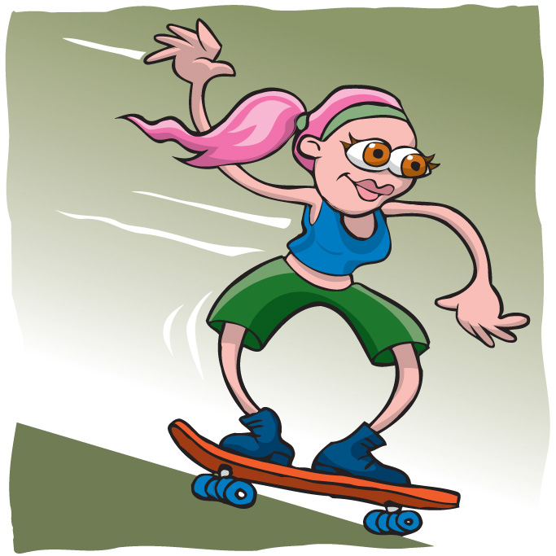  Is the girl in Figure 5.16 being sensible? Explain why or why not. Draw a picture of a girl behaving more responsibly in the same circumstances. | The girl is not wearing any safety gear. She could hurt her hands, elbows and knees if she fell. She could also hurt her head. The drawing should show the person wearing a helmet, knee and elbow pads and wrist protection.

Challenge
8.
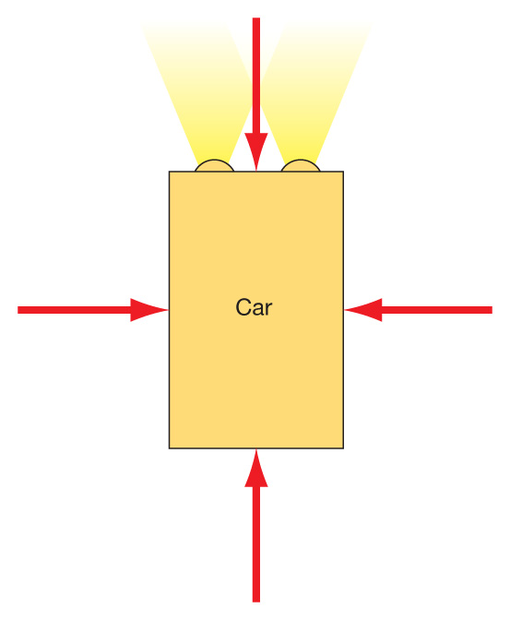
The rectangle in Figure 5.17 represents a stationary car. The forces acting on it are equal (balanced) in every direction. This is shown by the four arrows all of which are equal in size. Draw four rectangles like this one to represent four cars. On each of your cars draw the arrows to represent the change in the size of the forces as the car:
a. moves forward. | Force from the back will be greatest.
b. turns to the right. | Force from the left will be greatest.
c. moves at a constant speed with no change in direction. | All forces are equal.
d. slows down. | Force pushing the car back will be greatest.
9. Explain why it could be dangerous to wear shoes with worn soles when you are playing games such as tennis or netball. Devise a role-play to demonstrate your ideas. | There will be reduced friction between the shoe and the ground. The player could slip and fall.
10. Most sports depend on friction. Make a list of situations in a sport of your choice where friction is important. | For example - Good grip on the ground. Griping the handle of a racquet, bat or stick in games such as tennis or hockey requires friction. Catching or kicking a ball requires friction.
11. Develop a scenario to explain what happened in the seconds before the picture in Figure 5.18 and why it happened. | A possible scenario: The bike hit the stone and stopped suddenly. The bike rider continued forward. Gravity pulled the rider down to the ground and the force of hitting the ground stopped the rider from falling any further.

12. In the Queensland Transport safety campaign aimed at skateboarders, the slogan is ‘Stay pretty. Wear a helmet’.
a. Why is it an appropriate slogan? | If you do not wear a helmet and have an accident your face could be injured leaving permanent scarring.
b. Do you think this sort of message would influence the attitude of young people to the use of protective gear? Explain your response. | Own ideas.

Chapter 6 — Tomorrow’s weather

Chapter questions
6.1.1. Name three features of the atmosphere that are measured to help weather forecasting. | Temperature, wind speed and direction, rainfall, humidity, cloud type and cover, air pressure.
6.1.2. Explain the difference between the terms ‘maximum temperature’ and ‘mean maximum temperature’. | The maximum temperature is the highest temperature for a period of time such as a day. The mean maximum temperature is the average maximum temperature over an extended period such as a month or a year. It could be the average maximum temperature for a particular day of the year calculated using information for a large number of years.
6.1.3. What happens to water when it evaporates? | It changes into water vapour — a gas.
6.1.4. What is wind? | Moving air.
6.1.5. Which cloud type do we associate with rain? | nimbus
6.1.6. Compare the movement of air in a high pressure system and in a low pressure system. | In a high pressure system the air moves in an anti-clockwise direction. In a low pressure system the air moves clockwise.
6.2.1. What information do scientists use to learn about past climates? | Fossils in rocks and tree rings.
6.2.2. How is current climate change different from changes in the past? | There is scientific evidence that 15–20 million years ago Australia had much higher rainfall than it has today. Australia has also been colder. The last ice age finished about 10 000 years ago and since then Australia, along with the rest of the world has been warming up.
6.2.3. Why is the atmosphere important for our survival and for the survival of other living things? | All our weather occurs in the atmosphere and anything that affects the atmosphere has the potential to affect our weather and, in the longer-term, our climate.  The atmosphere prevents the heat from the sun from escaping back into space. Without the atmosphere the daytime temperatures on Earth would be a lot higher and the night time temperatures would be a lot lower
6.2.4. Which gas is produced when fossil fuels are burnt? | Carbon dioxide
6.2.5. Explain how a change in sea level could result from an increase in world temperatures. | As the temperature increases some of the ice at the Arctic, Antarctic and on the top of high mountain ranges will melt. This will add more water to the oceans and rivers causing the sea level to rise.

Review questions
Check
1. Complete Worksheet 6.10 to check your knowledge of the key terms used in this chapter. | See answers to worksheets.
2. Write the word WEATHER in upper case letters down the side of your page. Use each letter of ‘weather’ as the starting letter of word you could use when studying the weather. | W — water, water vapour, wind  E — evaporate  A — atmosphere  T — tropical cyclone, temperature  H — hail, heat  E — energy, Earth  R — rain
3. Explain the difference between weather and climate. | Weather changes over relatively short periods of time — hours or days. Climate is the general pattern to the weather that can expect in different parts of Australia (or the world) at different times of the year.
4. In the diagram in Figure 6.28, put the words – ‘condensation’, ‘precipitation’ and ‘evaporation’ in the correct boxes. | 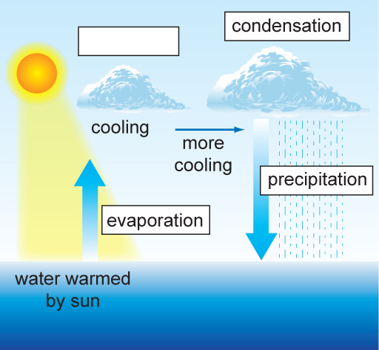

5. Draw a picture of a cumulus cloud, a cirrus cloud and a stratus cloud. Underneath each diagram record the way you remember the different cloud types. | 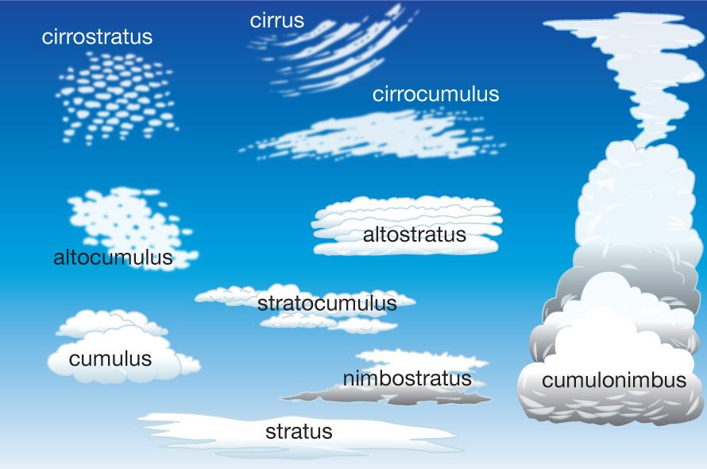
6. Describe the different ways that animals and plants could respond to climate change. | Animals could move to other areas where their food supply is available.  Plant seeds may establish in new areas.  Some plants and animals that are around today may become extinct.
Apply
7. 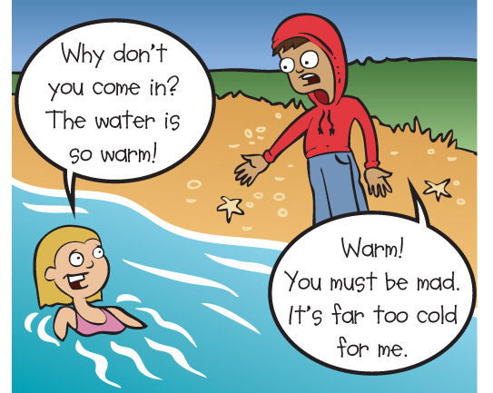  Suggest reasons for the two people in Figure 6.29 having such different ideas. | The people come from different parts of Australia or of the world. For the person who thinks it is warm the temperature at the beach would be higher than the temperatures where they have come from. For the person who thinks it is cold, their local temperatures will be higher.

8. Give two examples of situations where you have seen water vapour condensing to form water droplets. Explain why condensation occurred in these situations. | Condensation occurs where air containing water vapour is cooled. The water vapour changes state to become liquid water. Possible situations include — on the outside of a container that has been removed from the fridge and left on a bench, inside a window where the temperature in the room (or car) is warmer than outside, on the outside of the window of an air-conditioned room where the temperature outside is much warmer than inside.
9. a. Your friends were describing a storm they experienced on holiday. They said that the trees were bending over and that they found it very difficult to walk along the street. On the Beaufort scale what force would you use to describe that wind? | Force 7
b. What were the wind speeds? | 50–61 km/h
10. Consider Figure 6.30.
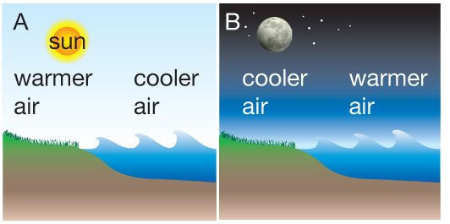
a. In what direction will the wind blow in these two situations? | Refer to Figure 6.11 and Figure 6.12 in section 6.1 in the student book.
b. At what time of day would you expect to have the conditions in picture A? Explain | During the day when the sun is warming the land.
11. On a weather map the isobars were very close together over Adelaide. On the same map there was a high pressure system over Perth. What do you think the weather would be like in these two cities? | There would be strong winds in Adelaide. Perth would be experiencing clear sunny weather.
12. Compare the conditions in the eye of a tropical cyclone with the conditions on either side of it. | In the eye of a tropical cyclone the conditions are calm. On either side of the eye there are very strong, destructive winds and rain.

13. Explain how fossils can give us information about climates in the past. | Plants and animals live in areas where the conditions suit them. The plants and animals give us an idea of what the climate and more local weather conditions are like in an area. This would be true in the past as well. The fossils found in rock tell us what animals and plants lived in an area in the past. If we know the sorts of conditions they lived in then we know something about the climate in that area in the past.
Challenge
14. Mime a scene where the weather plays a part. The other members of the class could explain what they understood by your mime.
15. When could knowing the mean maximum temperature and the mean minimum temperature for a month be more useful than knowing the temperature on a particular day of that month? Give reasons for your answer. | If you were planning to travel to an area knowledge of the mean temperatures would give you a more general picture of what to expect than knowledge of the temperature on one day. The one day temperature may be that of a particularly hot (or particularly cold) day.
16. The climate in Australia and the rest of the world has changed in the past. Why are people so concerned at the changes that appear to be happening now? | We are much more aware of climate the factors affecting climate now than we have been in the past. Human activity is possibly contributing to climate change and causing it to happen more rapidly than it would naturally. Plants and animals may be able to adapt to slow climate change but may not survive rapid changes.
17. Would all our problems be solved if all the greenhouse gases could be removed from the atmosphere? Explain. | Removal of all the ‘greenhouse gases’ would reduce the ability of our atmosphere to trap the warmth of the Sun. Removing them all would cause the temperatures of the Earth to become warmer during the day and much colder at night.
18. Find out more information about the effects of an actual tropical cyclone in Australia. | Own research.
- Where did it occur? | Own research.
- When did it occur? | Own research.
- What category was it? | Own research.
- What effects did it have on humans? | Own research.
- What effects did it have on the natural environment? | Own research.
- What are some other interesting things about the cyclone? | Own research.
Create a presentation to share your research with the class. | Own research.

Chapter 7 — Use it again

Chapter questions
7.1.1. Give an example of a renewable resource. | Examples include timber, plants and animals we use as food and a source of fibres such as cotton.
7.1.2. Explain why it is renewable. | Renewable resources can be replaced if they are used.
7.1.3. What is waste? | Anything that is not wanted in an activity
7.1.4. Explain the term biodegradable. | The materials in biodegradable wastes can be broken down (decomposed) in a natural environment by bacteria and fungi that live in the soil.
7.2.1. What percentage of aluminium and steel in cans is recyclable? | 100%
7.2.2. Explain why recycling aluminium and steel is a good idea. | They both are non-renewable resources and we will eventually run out of the raw materials.
7.2.3. Can all types of glass be recycled? Explain. | No. Some types of glass have substances added to them which cause problems in the recycling process. Examples of non-recyclable glass include oven proof glass, light bulbs and windscreen glass.
7.2.4. What changes have the manufacturers of glass bottles introduced to make better use of resources? | The amount of glass in the bottles is reduced.
7.3.1. Describe two characteristics that all plastics have. | Select from — lightweight, easy to mould, do not transfer heat and poor conductors of electricity.
7.3.2. Why are bottle tops made of different plastic from the main part of the bottle? | They need to have different characteristics. The bottle top has to be strong enough to be screwed on and off the bottle many times. However, the seal has to be weak enough to be broken the first time you open the bottle.
7.3.3. Which plastic is used for the bottle top? | High density polyethylene (HDPE)
7.3.4. Which type of plastic is used to make the bottle? | Polyethylene terephthalate (PET)
7.3.5. What benefit is there of having a coding system for plastics? | A coding system identifies these plastics making it easier to sort the plastics before recycling. Not all the plastics can be recycled in all places.
7.4.1. In the early years, which materials were replaced by plastics? | Metal, wood and china products
7.4.2. What characteristics are common to all plastics? | They are all lightweight, easy to mould, do not transfer heat, and are poor conductors of electricity.

7.4.3. What does the following symbol on plastic products tell us?  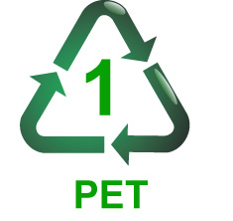 | It tells us they type of plastic that is used to make that product.
7.4.4. Who is responsible for the litter created by packaging? | The people who through the packaging away.
7.4.5. Which products are being used to make biodegradable plastics? | Wheat and corn starch
Review questions
Check
1. Use Worksheet 7.7 to check your knowledge of the key terms. | See answers to worksheets.
2. How are the characteristics of plastics changed to meet the needs of particular situations? | Different chemicals are added to the basic mixture.
3. Explain why it is expensive to make aluminium products from new resources. | Exploration for the bauxite takes a lot of time with many people and expensive equipment involved in the process. Mining the bauxite, transporting it to the processing plant and the processing take a lot of energy. The processing plants have to be built.
4. What happens to broken glass that is sent for recycling? | Broken glass is used in making bricks and in road base.
5. Explain why glass is sorted by colour before it is recycled. | The colour of the glass that is being recycled determines the colour of the final product.
Apply
6. Give two reasons why dumping waste in landfill is not the best idea. | Landfill sites take up a lot of space and we are running out of suitable space near the big cities. When things are dumped and buried in landfill all the materials that they were made of are buried with them. Some of these materials cannot be renewed.
7. What use can be made of biodegradable wastes that have been composted? | It looks like dry crumbly soil, rich fertiliser that can be spread on the garden adding nutrients to help plants grow.

8. Which resources are saved when the following are recycled?
- paper | Energy, water and trees.
- aluminium | Energy, coal and bauxite.
- Steel | Energy, coal, iron ore.
- glass | Energy, silica (which is found in sand), soda ash and limestone.
9. How many times could new products be made from the aluminium we are using now? | There is no limit to the number of times.
10. Explain why not all the plastic containers we buy are made of the same type of plastic. | The containers have different requirements.
Challenge
11. Suggest changes that you could make at home to increase the amount of recycling that takes place. | Own ideas
12. There is a suggestion that ‘rethink’ be added as a fourth word on the list of ‘Reduce’, ‘reuse’ and ‘recycle’. The idea is that you think twice before you buy something.
- How could this save resources? | We might not buy so many things that go into the bin in a very short time.
- How could people be encouraged to rethink? | Own ideas
13. Car and truck tyres can be used under very harsh conditions so they have to be made to last. Millions of tyres are thrown out every year and the materials from which they are made do not breakdown naturally. Tyres, therefore, represent a large amount of our resources. Research ways that tyres are reused and recycled and the uses made of the recycled materials. Prepare a presentation to share your information with the class. | Own research.

Chapter 8 — Water

Chapter questions
8.1.1. What is a catchment? | Areas of land drained by a network of creeks and rivers that eventually flow into a large river.
8.1.2. Why does a catchment have to be well managed? | Water flowing over the land picks up sediments, nutrients and other pollutants which are carried into the river and then downstream. Dams built across rivers store water and are very effective at trapping and holding nutrients and sediments and this can reduce water quality. Since the dams will be used as a source of drinking water it is important that the water is of good quality.  If the quality of water is to be maintained at a good level then the catchment has to be managed to:  - reduce the amount of sediment, nutrients (from fertilisers) and pesticides entering the creeks.  - prevent nutrients and pathogens (disease causing organisms) from waste from entering creeks.  - reduce soil loss and therefore sediments entering the water.
8.1.3. Why is it important that the water in rivers and dams is of good quality? | It is used for drinking. Water of poor quality may carry pathogens and it also becomes more difficult and expensive to treat it so that it reaches a satisfactory quality for drinking water.
8.1.4. What is evaporation? | The change of state from liquid to gas.
8.1.5. List two things that change the rate of evaporation. | The surface area of the water  The difference in temperature between the water and the air  Humidity  Wind
8.2.1. What do we mean when we say that water is turbid? | It is cloudy.
8.2.2. Why are diseases carried by water not common in Australia? | Because the water is treated before it is made available for drinking.
8.2.3. Name the four processes in water treatment that make it fit for drinking? | Coagulation, flocculation, sedimentation and filtration.
8.2.4. Which of the processes removes the smallest particles? | Filtration
8.2.5. What else is done to the water before it is ready to go into the distribution system? | The water is disinfected using chlorine or ozone to make sure that no bacteria remain.

8.3.1. Explain the difference between grey water and black water. | Grey water is the water from showers, baths and the rinse cycle of the washing machine in the laundry. Black water is the water from the toilet and kitchen.
8.3.2. a. On average how many litres of water are used by a family each day? | 800–1000 L per day.
b. How much of this is grey water? | 40–60%
8.3.3. How many steps of treatment does water go through between entering the sewerage system at your home and possibly being returned as drinking water in the future? | Seven
8.3.4. a. At how many stages in this process is water taken out and used for different purposes? | Four
b. what is it used for? | Gardens, irrigation and industry.
Review questions
Check
1. Use worksheet 8.8 to check your knowledge of the key terms. | See answers to worksheets.
2. Why is water so important to us? | Our bodies are nearly 70% water and without water we die very quickly.
3. Where is most of the world’s fresh water stored? | In the icecaps of the Arctic and Antarctic and underground.
4. Why are dams built? | Dams are built to store of water to meet the needs of people in large towns and cities to make sure that water is available even if there is no rain.
5. Explain why it is important that we drink only clean water. | Untreated water may carry pathogens that would make us sick.
Apply
6. Is less water available now that 100 or 200 years ago? Explain. | There is the same amount of water now as there was 100 or 200 years ago. However, it may be stored differently and less may be available for our use. Also previous sources of drinking water may now be polluted and not easily accessed as drinking water.
7. What can happen to reduce the quality of water in our dams? |  | Sediments and nutrients from farm land reduce water quality. Wastes from septic systems and from farmland may contaminate the water. These wastes may carry pathogens.
8. Why is there sometimes a strong smell of chlorine when we turn on the taps? |  | Chlorine is used to disinfect water to make sure that all pathogens are killed and the water is safe to drink.

9. Is the idea of recycling water unique to Australia and one that has just arisen because of the current drought? | No.
10. In your own words, describe what happens to water from the time it leaves your home in the sewerage pipes until it can be returned to the water distribution system. | Refer to Figure 8.14
Challenge
11. Should we be building more dams to increase the amount of stored water? Give two reasons to support your response and two reasons people might use as an argument against your idea. | FOR:  - As our population increases we need to capture as much water as possible. Dams are an effective water store.  - Dams use the natural contours of the land and once the dam is in place there is little maintenance required and no more disturbance of the area.  - Dams can be used for recreation and are an added resource for an area.  AGAINST  - A large amount of the stored water is lost by evaporation form the dam surface.  - Large areas of land are flooded and become unavailable for other uses such as farming – food production.  - Damming a river changes the water flow downstream and this changes the ecology of the river and the river banks. It may cause some animals and plants to become extinct.  - We should be encouraging people to make better use of the water we have rather than trying to make more water available.
12. In Australia, we use a large amount of underground water. Where does this water come from and is it an unlimited resource? |  | Some of the water comes from underground streams but a lot of it comes from the Great Artesian Basin. Some of the water is old — thousands or millions of years old and we are using it at a faster rate than it is being replenished. It is therefore not an unlimited resource.
13. How would you respond to someone who said that all the water on Earth is recycled water? Explain your response. |  | The water goes through the cycle of evaporation from water surfaces then condensation to form clouds. Precipitation as rain, hail or snow brings the water back to Earth. All the water we have available to us on Earth today has been through this cycle many times in the past.

14. Carry out research into the water supply for your area. | Own research
- Where does the water come from? | Own research
- How is it stored? | Own research
- How dependable is the supply? | Own research
- What projects are there to make used of stormwater and other forms of recycled water? | Own research

Chapter 9 — Energy converters

Chapter questions
9.1.1. What is energy? | Energy makes changes and causes things to happen around us
9.1.2. Explain the following terms:
- Kinetic energy? | Kinetic energy is moving energy.
- Potential energy? | Potential energy is stored energy.
9.1.3. Give two examples of potential energy. | Arrow pulled back in the string of a bow. Bal or book sitting on a table. Rock on the top of a cliff. Water at the top of a waterfall.
9.2.1. Where does most of the energy used on Earth come from? | The Sun.
9.2.2. Name the process plants use to trap energy from the Sun. | Photosynthesis.
9.2.3. What form of energy stored in food, coal and oil? | Chemical potential energy.
9.2.4. What form of energy is most commonly used by modern society? | Electricity.
9.2.5. When a jumbo jet is flying through the air at about 300 km/h, what type of energy does it have? | Kinetic energy because it is moving. It also has potential energy because it is above the ground.
9.3.1. How is a renewable source of energy different from a non-renewable source? | Renewable energy sources can be replenished in a short time. The supplies of non-renewable energy sources are limited and once supplies are used up we cannot get any more.
9.3.2. Why is it difficult to use the energy from the Sun directly? | The Sun’s energy is spread over a large area and is therefore difficult to capture.
9.3.3. Name two renewable sources of energy that can be converted to electrical energy. | Wind, the Sun, falling water (hydro energy) and biomass.
Review questions
Check
1. Use words from the key terms to complete the crossword in Worksheet 9.9. |  | See answers to worksheets.
2. Coal is one of Australia’s natural resources. What is most of the coal used for? |  | To produce electricity.
3. What are two ways we are able to use the Sun’s rays directly as a source of energy? |  | To heat water and in photovoltaic cells to produce electricity.
4. When you play sport, you use kinetic energy. Where did this energy come from? |  | From the energy stored in the food you ate.

5. Biomass and coal both come from plants, yet biomass is called a renewable energy source and coal is non-renewable. Why is there this difference? | Biomass can be regrown in a relatively short time therefore it is a renewable resource. Coal takes millions of years to produce and cannot be considered as renewable.
Apply
6. Look up the word ‘potential’ in a dictionary. Explain why this word is used to describe stored energy. | Potential means possible rather than actual. Potential energy is energy that something has stored in it. I may never actually be used.
7. a. Electric water heaters are usually found at the side of a house. If the house has a solar water heater where would you expect to find it? | On the roof where it will be in full sun most of the time.
b. Could the people living in the house depend on having an unlimited supply of hot water every day? Justify your answer. | No. Solar water heaters do not work well on cloudy days so they may not be able to depend on a constant supply of hot water.
8. Draw a diagram to show the energy conversions that take place in a DVD player and an electric toothbrush. | Electrical energy sound, heat, light, kinetic energy  Electrical energy kinetic energy, sound, heat
9. Windmills have been around for a long time.
a. What were the early windmills used for? | To grind grain and to pump water from land that was once under the sea.
b. What form of energy would now be used for those purposes? | Electrical energy
c. What are modern windmills used for? | Generating electricity.
Challenge
10. If you trip over you might graze your knee. If you fall out of a tree or off a wall, you are likely to have more serious injuries. Use your understanding of energy and energy conversions, to explain why falling out of a tree can be more dangerous than tripping over. | When you fall from a greater height you have more potential energy. The more energy you have when you hit the ground the greater the potential damage to your body.
11. Even when you are sleeping or sitting still you are using energy. What are some of the things going on inside your body that you need energy for? | Heart beating, breathing, blood circulating, digestion of food, repair of damaged cells, brain activity (dreaming, awareness of sounds)

12. a. Draw a flow diagram that identifies the main events that occurred as the plants growing 300 million years ago were changed to the electricity we use today. | Refer to Figures 9.11 and 9.13 in section 9.2 in the student book.
b. What energy conversions have occurred in this process? | Solar energy to chemical potential energy (in plants) to heat energy (as coal is burnt) to kinetic energy (as the turbine is turned) to electrical energy.
13. Water, wind and coal are all used to generate electricity. What part of the process is the same in each case? | The turning of turbines to generate the electricity.
14. Create a futures wheel of ‘A world without electricity’. | Own ideas.

Chapter 10 — Under the skin

Chapter questions
10.1.1. What are the seven characteristics of living things? | Movement, respiration, sensitivity, growth, reproduction, excretion, nutrition.
10.1.2. What is a system? | A system is made up of many parts that work together
10.1.3. Describe the movement of your diaphragm and ribs as you breathe in. | The diaphragm contracts and flattens. The ribs move up and out.
10.1.4. Which gas moves from the air in the lungs into the blood? | Oxygen.
10.1.5. Explain the difference between an organ and a system. | An organ is a part of a system.
10.2.1. Which two parts are present in plant cells that are not present in animal cells? | Cell wall and chloroplasts.
10.2.2. What do we mean when we say that cells are specialised? | Specialised cells have a special job to do and their structure will make them better able to do their job..
10.2.3. What is the outer layer of a plant cell? | The cell wall.
10.2.4. What is the outer layer of an animal cell? | The plasma membrane.
10.2.5. Which part of the cell is the ‘control centre’? | The nucleus.
10.3.1. Why do we place organisms in groups? | To make communication easier.
10.3.2. Name the five kingdoms. | Animals, Plants, Fungi, Protists, Monerans
10.3.3. What happens to the groups as you move down the classification from kingdom to species? | The individuals in the group become more alike.
10.3.4. What characteristic is used to separate animals into the groups vertebrate and invertebrate? | Vertebrates have a back bone (vertebral column). Invertebrates do not have a back bone.
Review Questions
Check
1. Complete Worksheet 10.7 to check your knowledge of the key terms. |  | Se answers to worksheets.
2. What does the mnemonic MRS GREN represent? |  | The seven characteristics of living things.
3. What cell parts are found in:
a. both plant and animal cells? |  | Nucleus, cytoplasm, plasma membrane.
b. plant cells only? |  | Cell wall and chloroplasts.

4. a. How did cells get their name? |  | They were named by Robert Hooke who first described them. He called them cells because they resembled ‘a honeycomb with a great many little boxes’. The word cell comes from the Latin for ‘little room’.
b. Who gave them this name? |  | Robert Hooke
5. Why do we need to place living things into groups? |  | Because there are so many different types of living things it is difficult to talk about them individually. It is easier if they are placed in groups.
6. Name two of the kingdoms. Describe the characteristics that make them different from each other and the other kingdoms. |  | Monerans — the complete body is only one cell. There is no organised nucleus.  Protists — the complete body is only one cell. There is a distinct nucleus.  Fungi — includes organisms that are single cells and also the large toadstools and bracket fungi.  Plants — made of many cells that are organised into tissues and organs. The cells have cell wall and some cells contain chloroplasts.  Animals — made of many cells organised into tissues and organs. Cells do not have a cell wall.
Apply
7. In an organism made up of many cells, the cells are ‘specialised’.
a. Explain what this means. | All living things have to carry out a large number of activities to stay alive. In single celled organisms the one cell carries out all the functions. In organisms with many cells some cells will carry out some of the functions and other cells will perform different functions. The cells are specialised when they have a limited number or functions to carry out.
b. Suggest ways that cell specialisation is a benefit to an organism. | The shape of the cell and its contents can make it more efficient at carrying out a particular task.
8. a. Place these three terms in order from the one that has the most cells to the one that has the least — ‘organ’, ‘tissue’, and ‘system’. | System Organ Tissue
b. Explain the difference between them. | Tissue is a group of cells of the same type. Many different tissues are found in an organ and many different organs are found in a system.

9. Draw diagrams showing the main parts of:
a. a plant cell | The plant cell should contain a cell wall, cytoplasm, plasma membrane, chloroplasts and a nucleus.
b. an animal cell. | The animal cell should contain cytoplasm, plasma membrane and a nucleus.
10. a. If an unknown ‘thing’ was discovered by explorers, how would biologists decide whether or not it was a form of life? | Study it and look for the seven characteristics of living things.
b. If they decided it was living, how would they decide to which kingdom it belonged? | Look to see if it was made of more than one cell and then look for the presence of a cell wall and chloroplasts.
Challenge
11. Carry out some research into other systems of your body. |  | Own research
- list the major organs of the system. |  | Own research
- Describe the function of the system? |  | Own research
12. What do you think would happen if the nucleus of a cell was damaged? Give a reason for your answer. |  | The cell would probably die because the nucleus controls the activity of the cell.
13. Why do you think that our knowledge of cells is linked to the developments and improvements in microscopes? |  | As we have wanted and needed to know more about cells the instruments we use to observe them have had to improve.
14. There are organisms in each of the five kingdoms that are harmful and helpful to humans. |  | Own research
Research two organisms in each kingdom, one that is helpful, and one that is harmful. |  | Own research
For each organism: |  | Own research
- give its name |  | Own research
- describe where it is found |  | Own research
- describe what it does to or for humans that allows it to be called helpful or harmful. |  | Own research

