2.3 Obtaining nutrients – Questions and answers

Q1.
Bk Ch2 S2.3 Q1
Define the following terms, and provide examples of each:
a tissue
b organ
c system.

A1.
Bk Ch2 S2.3 A1
Tissues are groups of similar cells that work together to perform a particular function. Example: muscle tissue in the lining of the stomach.
An organ is a group of different tissues that work together to perform a particular function. Example: the stomach is an organ composed of muscle tissue, epidermal tissue and vascular tissue.
A system is a group of organs that work together to perform a particular function. Example: the digestive system includes such organs as the stomach and intestine.

Q2.
Bk Ch2 S2.3 Q2
Cell specialisation in multicellular organisms is an adaptation that allows all of the organism’s requirements to be met. Complete this table, showing some different kinds of specialised cells in multicellular organisms and their functions.

Cell type | Plant/animal | Diagram | Function | How structure relates to function
Nerve cell |  | 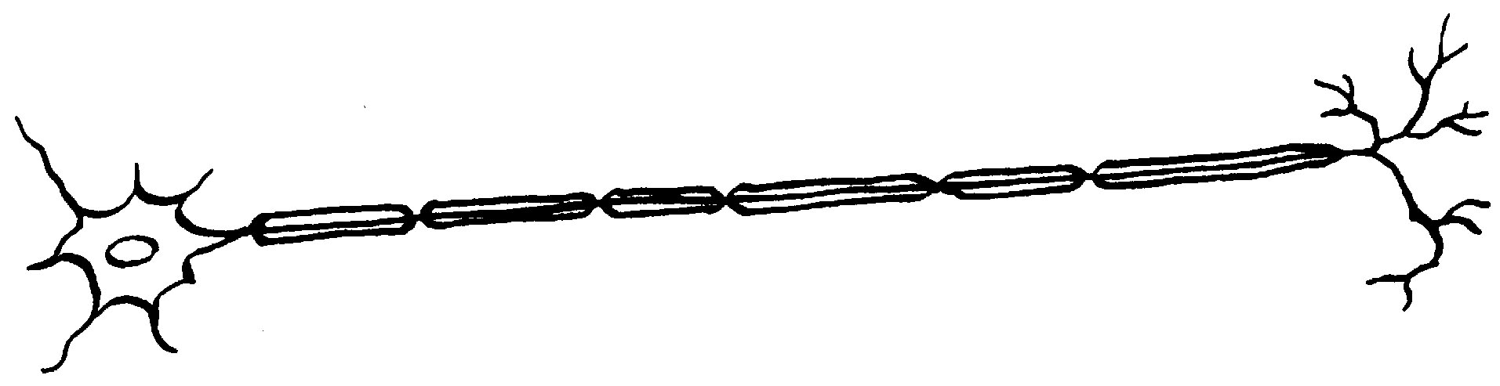
Lining cell of small intestine |  | 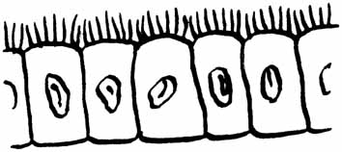
Root hair cell |  | 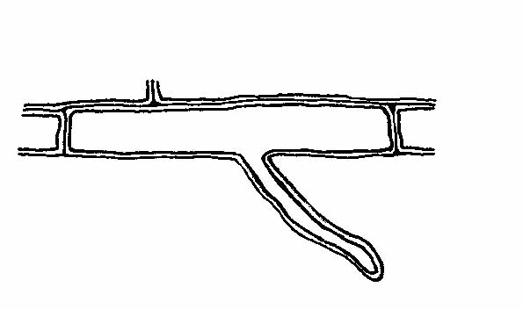
Leaf mesophyll cell |  | 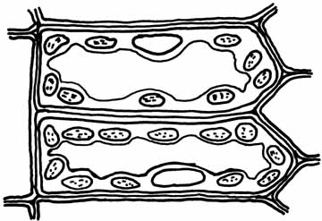

A2.
Bk Ch2 S2.3 A2

Cell type | Plant/animal | Diagram | Function | How structure relates to function
Nerve cell | Animal |  | Carries nerve impulses from one part of body to another | Extension of cytoplasm allows impulses to be carried over long distances
Lining cell of small intestine | Animal |  | Absorbs nutrients | Villi (of folded cell membrane) increase surface area of cell, maximising absorption
Root hair cell | Plant |  | Absorbs mineral nutrients from soil | Extension of cell increases surface area, enhancing efficiency of absorption
Leaf mesophyll cell | Plant |  | Carries out photosynthesis | Contains many chloroplasts, which increases the amount of glucose produced in photosynthesis

Q3.
Bk Ch2 S2.3 Q3
Distinguish between the autotrophic and heterotrophic nature of plants and animals.

A3.
Bk Ch2 S2.3 A3
Plants are autotrophic organisms, that is, they are ‘self-feeding’; the green cells of plants contain chloroplasts which photosynthesise, producing their own organic nutrients. Animals are heterotrophic; they cannot produce their own nutrients and so rely on eating plants or other animals that eat plants in order to obtain organic materials.

Q4.
Bk Ch2 S2.3 Q4
Explain the following statement: ‘All living things depend on plants.’

A4.
Bk Ch2 S2.3 A4
All living things need organic materials as a source of energy. Organic substances are produced by plants in the process of photosynthesis. Animals do not photosynthesise and so rely on plants to obtain these materials. Animals either eat plants directly or eat other animals that eat plants.

Q5.
Bk Ch2 S2.3 Q5
Write out the word equation that summarises the process of photosynthesis.

A5.
Bk Ch2 S2.3 A5
carbon dioxide + water $\underset{\text{chlorophyll}}{\vec{\text{light energy}}}$ sugar + oxygen

Q6.
Bk Ch2 S2.3 Q6
a Compare aquatic and terrestrial plants in relation to the site of water and mineral uptake.
b Terrestrial plants need a large surface area in order to maximise water uptake. How is this achieved?

A6.
Bk Ch2 S2.3 A6
a Aquatic plants generally have their entire bodies submerged in the water. Such plants can absorb water and minerals from their external environment directly into their bodies across the plant surface. Terrestrial plants obtain water and minerals from the soil through their root systems.
b The root systems of terrestrial plants are extensive and their surface area is further enhanced by the presence of root hairs, which are the site of water uptake. This large surface area increases the efficiency of absorption by terrestrial plants.

Q7.
Bk Ch2 S2.3 Q7
Explain how the structure of typical leaves and the distribution of specialised tissue within them is an adaptation to photosynthesis. Use clearly labelled diagrams in your answer.

A7.
Bk Ch2 S2.3 A7
The structure of leaves is an adaptation to photosynthesis. Leaves are broad, thin and flat. This feature gives leaves a large surface area to capture sunlight and exchange carbon dioxide and oxygen with the environment.

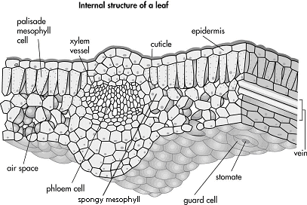

The cuticle is a waxy layer that covers the leaf, reducing water loss from the leaf surfaces.
The outer layer of cells or epidermis is transparent, allowing sunlight to penetrate to the photosynthetic cells beneath. The epidermis also contains specialised cells called guard cells that have a central pore or stomate through which gaseous exchange occurs with the external environment.
The mesophyll cells, which are the main site of photosynthesis within the leaf, form a couple of central layers in the leaf. The uppermost layer is called the palisade layer and is composed of elongated cells that are packed with chloroplasts. The spongy mesophyll is found below the palisade layer. It is made up of loosely packed, chloroplast-containing cells. The air spaces between the cells allow movement of gases and water vapour between the leaf cells and the stomates.
The veins in leaves are composed of two types of tissue: xylem and phloem. The xylem carries water from the roots to the leaf cells; phloem transports the products of photosynthesis from the leaves to other parts of the plant. All cells of the leaf are in close proximity to the vascular tissue.

Q8.
Bk Ch2 S2.3 Q8
a Explain the difference between mechanical and chemical digestion.
b Teeth are involved in the process of mechanical digestion. Describe the significance of their role in terms of preparing foods for chemical digestion.

A8.
Bk Ch2 S2.3 A8
a Mechanical digestion is the physical breakdown of large food particles into smaller food particles. Chemical digestion involves enzymes, which change the chemical nature of food particles, reducing them to simpler molecules.
b Teeth physically break large food particles down into smaller food particles. This increases the surface area available for enzymes to begin chemical digestion of the food. An increased surface area means that more enzyme can work on the food at a given time and therefore increase the efficiency of the digestive process.

Q9.
Bk Ch2 S2.3 Q9
Identify the structures labelled W, X, Y and Z in the diagram of the herbivore digestive system shown. What is the major function of each structure you have identified?

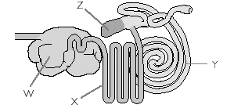
A9.
Bk Ch2 S2.3 A9

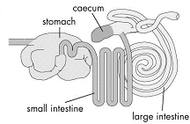

Stomach: chemically digests cellulose.
Small intestine: absorbs digested materials.
Caecum: carries out fermentation (cellulose digestion by bacteria).
Large intestine: absorbs water and some vitamins from contents of gut; undigested material leaves body as faeces.

Q10.
Bk Ch2 S2.3 Q10
Outline the importance of villi and microvilli in the digestive system.

A10.
Bk Ch2 S2.3 A10
The villi and microvilli lining the small intestine greatly increase the surface area for the absorption of digested materials.

Q11.
Bk Ch2 S2.3 Q11
a Compare the digestive systems of dogs (Figure 2.54) and koalas (Figure 2.57). Include a description of their respective digestive systems, commenting on length, complexity and role of different structures.

b Make a statement relating the length and complexity of the digestive systems of dogs and koalas to the chemical composition of their respective diets.

A11.
Bk Ch2 S2.3 A11
a While the general form of the digestive system of a dog and koala is similar, variations in some structures are obvious. The digestive system of the dog is shorter and simpler than that of the koala. Chemical digestion occurs in the stomach and absorption is the major function of the small intestine in both. However, the koala has a very much enlarged caecum compared to the dog. This is because the koala is a herbivore and must digest cellulose. The caecum contains bacteria that ferment the cellulose, chemically reducing it to simpler molecules that can be absorbed.
b The dog is a carnivore with a diet consisting almost exclusively of meat whereas the koala is a herbivore consuming only eucalypt leaves. Because there is no cellulose in meat protein it is relatively simple to digest and the simpler structure of the digestive system of the dog reflects this. Cellulose is a complex molecule that cannot be broken down by the digestive system of most animals. The caecum of the koala is enlarged to accommodate a large population of bacteria that ferment the cellulose, breaking it down to simpler molecules that can be absorbed, hence the longer and more complex structure of the koala’s digestive system.

